**Scheme**

1. **Introduction to scheme.org**

Schema.org takes care of all the structured data needs on your website. Search engines like Google can pick up this data and present your page in an enhanced way if you use it to describe products, reviews, events, and recipes.

The major search engines, Google, Bing, Yandex, and Yahoo, collectively developed this vocabulary to reach a shared language to understand websites better.

example :  
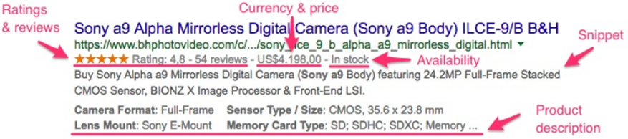

Note: when we prepare the scheme Object once, it will appliacble for web and ipad and mobile screen also , so no need of writing the scheme Object for each media screeen  
that one scheme Object for all screen

1. **All About Scheme  
   a)** scheme m chesthadi anthi, Google ki infromation echesthadi about our website, so google work load thaguthadi i.e google don’t go into our website content , it just use the scheme Object for displaying the rich snippets in the google search and google use these scheme infromation for Google maps and reviews, and etc

**b)** there are many different way for preparing scheme, like writing for the hotols, airlines and e-commmerance website,   
NOTE: all of them as follow same stand approch, just the text and content will changes, we must write the content and text according the content which we are preapring and taking the help of Offical documenets of scheme.org and google

**c)**  Use structured data markup on your product landing pages to help Google retrieve up-to-date information about your products and offers directly from your website.

**d)** Here we state(and this is the very least you should include):   
  **1. The type of company   
 2. The company name   
 3. Official website   
 4. Address  
 5. The official logo   
 6. The preferred description   
 7. The social accounts   
 8. The unique identifying URL**

**e)** The process is really simple - you just choose the Schema type like recipe or hotel or Organization and mark all the needed elements on your webpage. And Use structured data markup on your product landing pages to help Google retrieve up-to-date information about your products and offers directly from your website.

**f)** JSON-LD format is a more popular method of adding Schema markup manually. What's more, this method is recommended by Google. It's also easier to understand and deploy than Micro data or other outdated formats like RDF or Micro formats.

1. **3rd party website provide a service to prepare the Scheme**

**a)** 3rd party site generate the scheme Object file for us, by just providing the basic information about our company or website

**b)** some of website links are  
 1) <https://technicalseo.com/tools/schema-markup-generator/>   
 2) <https://hallanalysis.com/json-ld-generator/>   
 3) <https://www.rankranger.com/schema-markup-generator>   
 4) <https://technicalseo.com/tools/schema-markup-generator/>

1. **Offical website for scheme Preparation and refrence**
2. scheme offical website validator : <https://validator.schema.org/>
3. Google rich testing tool : <https://search.google.com/test/rich-results>

1. Google scheme Guidelines : <https://developers.google.com/search/docs/advanced/structured-data/recipe>
2. Officalwebsite of the microData : <https://html.spec.whatwg.org/multipage/microdata.html#microdata>

1. **Some of Examples**

**These are the few Real example of the schema data which we can achieve using the scheme Object**

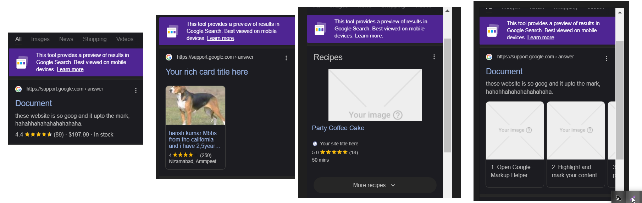

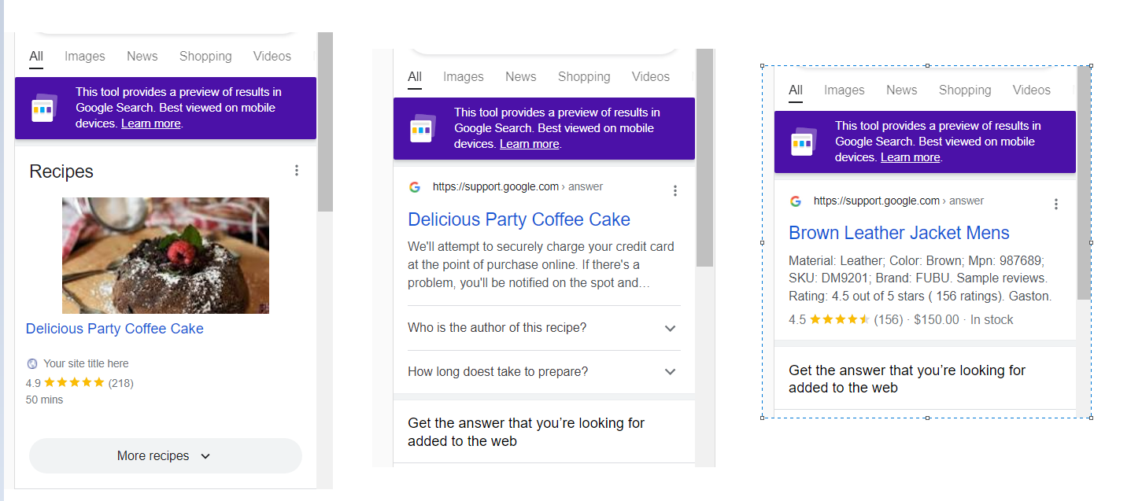

1. **Scheme Overview**
2. we dont have any html tag to write these kiind of results   
   so by using the scheme data we can achieve these kind of resullts in our code so we use scheme Object to prepare like these
3. Structured data is a standardized format for providing information about a page and classifying the page content.
4. **Scheme benefits**
5. **Add additional semantic to page content I**
6. **Improve the accuracy of the result**
7. **Increases the accuracy of site indexing by search engines**
8. **Increase CTR**

1. **Types of preparing the scheme Objects**

**There 3 types of preparing the scheme Object**

1. **RDFA format**
2. **Introduction**  
   W3C Specification  
    Uses attributes to integrate chosen vocabulary.   
   Closely marry to microdata RDFa Lite is smaller subset of RDFa designed to be easier to use.
3. **Example**

  <**li** property="recipeInstructions" typeof="HowToStep" vocab="https://schema.org/">

<**span** property="text">Preheat the oven to 350 degrees F. Grease and flour a 9x9 <**span**>

   </**li**>

1. **Micro-data format**
2. **Intro**  
   1) Originally introduced by WHATWG HTML5 Group.  
   2) Uses attributes to create name/value pairs that identify content. 3) Study done by webdatacommon says that 50.5% websites uses microdata to structure their pages.   
    4) First to adopted by google, bing, yahoo and yandex as the preferred structured data syntax.
3. **Example**

<**div** itemscope itemprop="mainEntity" itemtype="https://schema.org/Question">

<**h3** itemprop="name">Who is the author of this recipe?</**h3**>

<**p** itemscope itemprop="acceptedAnswer" itemtype="https://schema.org/Answer">

<**span** itemprop="text">

  Lorem ipsum dolor sit amet consectetur adipisicing elit. Eius voluptatibus molestiae quam sed

</**span**>

</**p**>

 </**div**>

1. **JSON Format**
2. **Intro**

1) Uses JSON to store structured data in embedded scripts.  
2) Abstracts the data from the structure of the web page.   
3) W3C Specification Google's favorite syntax to markup your site.

1. **Example**

   {

        "@context": "https://schema.org/",

        "@type": "Event",

        "name": "The Adventures of Kira and Morrison12",

        "description": "The Adventures of Kira and Morrison is coming to Snickertown in a can’t miss performance.",

       "image": "http://www.lacm.edu/wp-content/uploads/2017/03/kira-morrison-lacm-recital-march-17-2017-6451-uai-1800x1199.jpg",

}

1. **NOW Lets see one Real example in code in JSON ld format**

**(for coding , please see another file, where I explained all about coding in that file)**

<**script** type="application/ld+json">

      {

        "@context": "http://schema.org/",

        "@type": "Recipe",

        "name": "Delicious Party Coffee Cake",

        "datePublished": "2020-03-16",

        "description": "This coffee cake is awesome and perfect for parties.",

        "image": "https://www.washingtonpost.com/rf/image_982w/2010-2019/WashingtonPost/2022/02/17/Food/Images/v-essential-carbonara_34.jpg",

        "recipeYield": "10 servings",

        "prepTime": "PT20M",

        "cookTime": "PT30M",

        "totalTime": "PT50M",

        "recipeCategory": "Cake",

        "recipeCuisine": "French",

        "aggregateRating": {

          "@type": "AggregateRating",

          "ratingValue": "4.9",

          "bestRating": "5",

          "reviewCount": "218"

        }

      }

    </**script**>

The Above code has again so much line , but I have just keep few line of code here just for demo ( if u want to see the complete code please see the another word file, where I completed discussed about writing of the code)

Anyhow when we test our above code in the google rich testing tool we will get outpu like these, as shown in the below photo

**Output (left image is for mobile and web and right image for Google assiatance)**

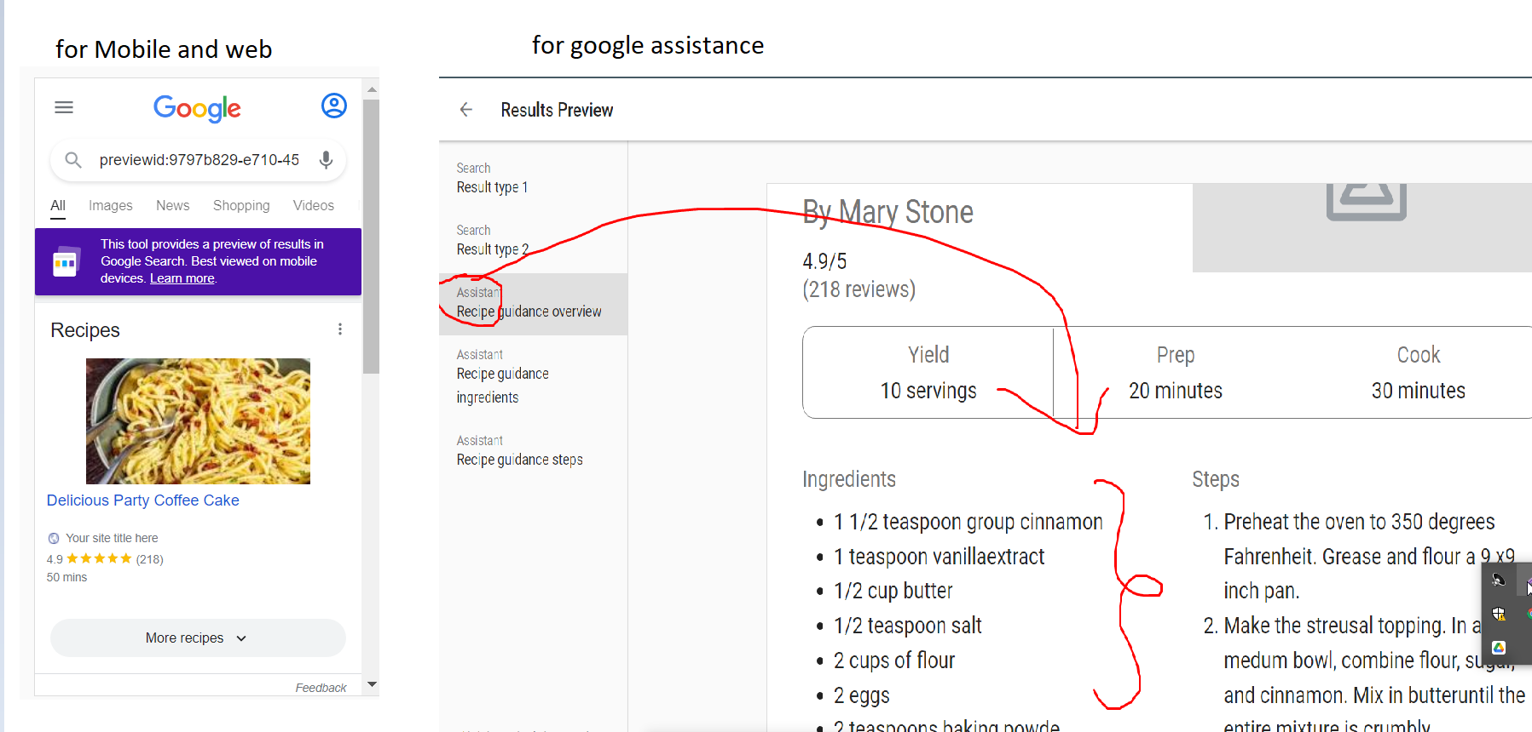

1. **Keep in Mind before while preparing the scheme Object**
2. There is no specific rule that we must use these one only or not, according to the our website, we will prepare the scheme object, but here name and images are mandatory becoz its recommend by Google
3. NOTE : what we are writing in scheme Object all the properties are not showen in the UI part, just those property are taken by the Google which Google wants but other property also we must and should need to mention in our code so that google has a good understanding of our recipe or any scheme Object
4. how do i know that we must use these property only while preparing the schema Object ani, anthi, according the content which we have using in our website, we must search that name in scheme.org website in recipe category then we must use that one here anthi
5. 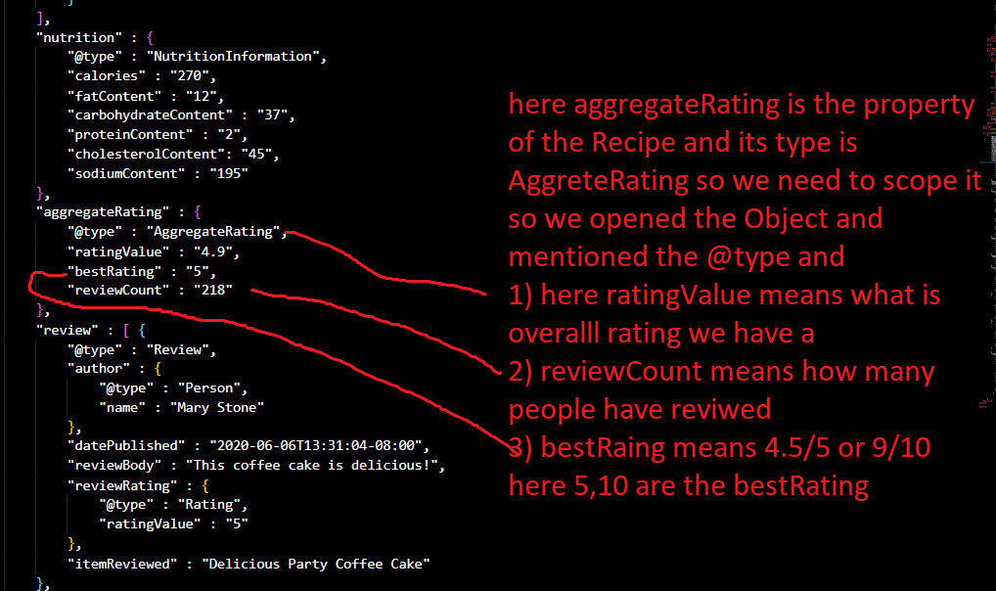
6. **@content property** in the json ld formart, specifies what object ur using ani example scheme.org(NOTE: there are so many other website which provide scheme object preparation so we need to specify the what website and what procedure we are following ani)
7. @type specifics which type thing ur using in ur code ani, like Recipe,FAQ, Events etc..
8. remaing alll the property we must need according to our website content NOTE: there are some mandatory propery we need to write at anycost, while compiling these Scheme Object in google rich testing tool , will suggest us and we need to write those alll properties
9. for example when we write location and came to know its a sperate entry, then we need to open the Object({}i.e flow brakets) and need to specify all the property which are mandatory for us in that file THEME when u encounter a sperate entry (like address,offer) we need to open the {} and write its property
10. NOTE: we need to write all the property which we are using in our website then we need to test the code in the rich testing tool, if anything is missing the it will give warming or error, then we need to fill or add all the deatiles in our scheme Object, there is no strict rule that these are imp, everytime, we need to follow the google Google guidleness(thier offical website and we need to prepare the scheme Object
11. For example in our Recipe example, the main mandatory property are name and Image as per the Google guidelines, u may think know do I know that these 2 fields(name and images) are mandatory , plz check the google docs(<https://developers.google.com/search/docs/advanced/structured-data/recipe> ) they mentioned all the mandatory properties and recommened properties in their google docs  
    same rule is applicable for the all the hotel and products and organizations

1. **Role of the Meta tags**

Meta tags are not shown in the page, but its machine parsable it means, google robo/crawlers will use these infrormation and

Play major role in scheme Object also

1. Example :
2. <meta charset="UTF-8">  
   <title>This is the meta title tag. It can be 45-60 characters long</title>

<meta name="description" content="This is the meta description. The maximum length is somewhere around 150-160 characters, but Google often pulls a description from your page content." />  
  <meta name="keywords" content="HTML, CSS, JavaScript">  
  <meta name="author" content="John Doe">  
  <meta name="viewport" content="width=device-width, initial-scale=1.0">

1. When we don’t have any scheme Object in our project then Google will use these meta tags for displaying the rich content in the Google search for example see the below example
2. 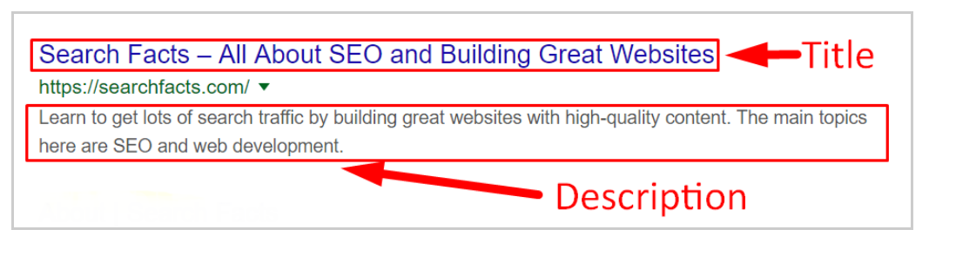
3. To learn about meta tags

<https://www.w3schools.com/tags/tag_meta.asp> visist these page

1. when user type something in the google seach and when these title or description match with the user search value then our website will come in top in seach results